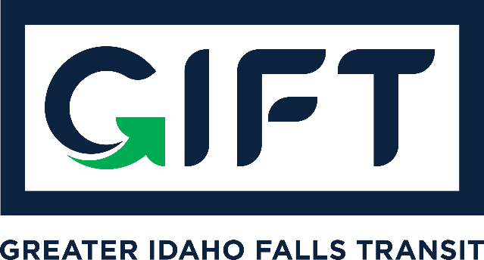

dba TRPTA TARGHEE REGIONAL PUBLIC TRANSPROTATION AUTHORITY
PHONE: 208-612-8323

BOARD MEMBERS:
Michelle Ziel-Dingman, Lisa Farris, Arnold Cantu, Rick Cloutier, and Michael Walker
BOARD MEETING
Tuesday January 19, 2021
9:00 am - 10:00 am - Idaho Falls City Annex Building - Small Conference Room
Agenda:
- Presentation ITD - Summer Hirschfield (Possible Action);
- Introduce new board member, Mike Walker;
- Approval of minutes from Dec. meeting;
- Bankruptcy update;
- Finance update;
- Survey update.
Action Items:
Approve minutes from 12/15/20 meeting;
Possible Action - Regarding presentation by Summer Hirchfield.

Other items:

Next Meeting: February 16, 2020 10:00 am - 11:00 am - Idaho Falls City Annex Building
Small Conference Room

